ALEKS Online Math Placement Testing Instructions for Students
Please read the information below carefully and make sure you have all the resources needed to take the test remotely. If you do not have all the required resources, please use the link, https://www2.registerblast.com/hacc/Exam/List to schedule an on-campus testing appointment.

If you require testing accommodations, please contact Elisa Cohen, escohen@hacc.edu.

IMPORTANT: The ALEKS Math Placement Assessment includes a practice assessment (Placement Assessment 1) which is an unproctored assessment and can only be used for self-evaluation to check your strengths and weaknesses in math. The Prep and Learning Module(s) can be used to learn new materials or to refresh your math knowledge. You must complete a Proctored Placement Assessment to determine your math class placement.

Required Materials and Resources for at-home Math Placement Testing
- A computer (desktop or laptop) with a webcam, audio, and stable internet connection. Phone and Chromebook are NOT compatible with the test requirements. For a proctored ALEKS placement assessment, Please click here to download and install the Respondus Lockdown Browser with Webcam.
- Please have your photo ID (Student ID, Driver’s License, Passport, or other government issued ID) ready before starting the proctored exam.
- You will be asked to scan your workspace. Please make sure your workspace is clear of any unauthorized materials or electronic devices, such as cellphone or calculator.
- You should find a quiet space to work alone. You are not allowed to communicate with any other person or get outside assistance.
- You are allowed to use blank scratch papers and writing utensils. ALEKS will provide an on-screen calculator if you need one to complete a particular problem. You are not permitted to use a personal calculator.
- You have up to two hours to complete the practice or proctored assessment.

Step-by-Step Instructions for Proctored Math Placement Assessment in Lockdown Browser with Respondus Monitor
- Navigate to ALEKS Math Placement Assessment Page, and use your myHACC login credential to access your ALEKS account. Bookmark this link for future reference and access to Learning Modules.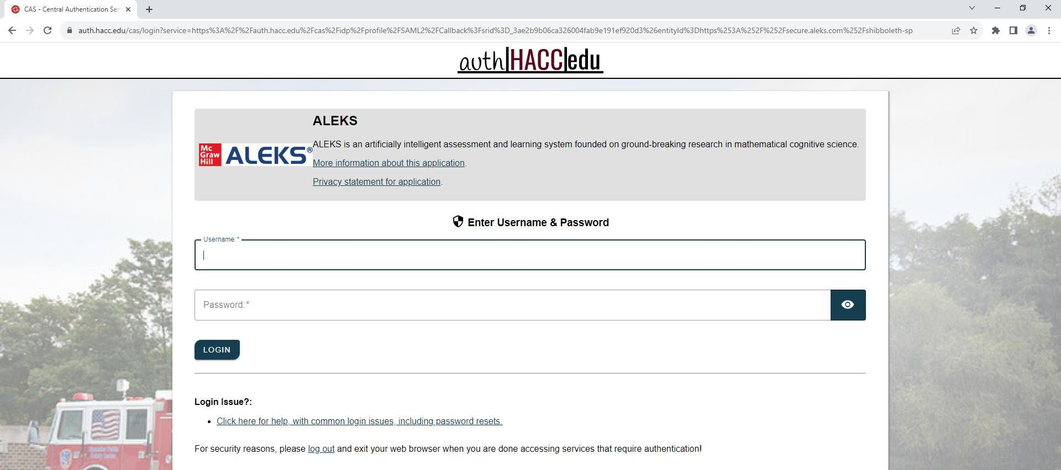
- You will be redirected to your ALEKs account with “Math Placement-Practice and Proctored, Summer/Fall 2024/Higher Education Math Placement” exam option as listed in the picture below. Please select the exam option.
*Note: If you don’t see the exam name listed, please click “Add Class” and enter 10-digit class code: FXKEH-HNUEX to get to the assessment.
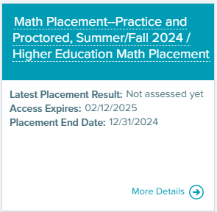
At the start of the test, you will be prompted to complete a brief survey, and then you will go through a brief tutorial about the system and how to enter answers, how to use the ALEKS calculator, and how to access ALEKS graphs.
Please Note: This ALEKS Math Placement Assessment is designed for students to take an unproctored practice assessment (Placement Assessment 1) to evaluate your strengths and weaknesses, and then use Prep and Learning Module(s) resources to prepare for the proctored assessment. It’s highly recommended that you complete the unproctored practice assessment before doing the proctored assessment; however, the unproctored/practice assessment is not required before taking the proctored assessment. (See step #5 for instructions to take proctored assessment.)
- To continue with the unproctored practice assessment, please click GET STARTED

- After completing the practice assessment, you will be provided with customized Prep and Learning modules for review and learning. It is recommended to work for a minimum of three hours before attempting the proctored assessment.
- When you are ready for the proctored assessment, please click ⓘ button under “Attempt 2 of 3” and next to Proctored/Unproctored.

- Click “Placement Assessment Override” option to enter the password.
- Enter FALL2024 and click Submit Password 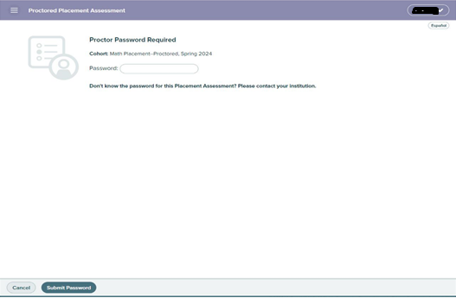

- Next, click “Launch LockDown Browser + Webcam” to launch the exam in a lockdown browser.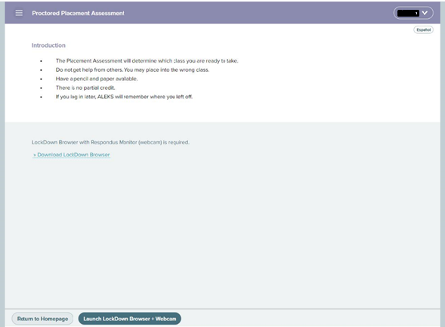
- If the Respondus LockDown Browser + Webcam is installed before starting the test, the assessment will open in a Lockdown Browser. Select “I want to use a webcam (Respondus Monitor)” and click continue.
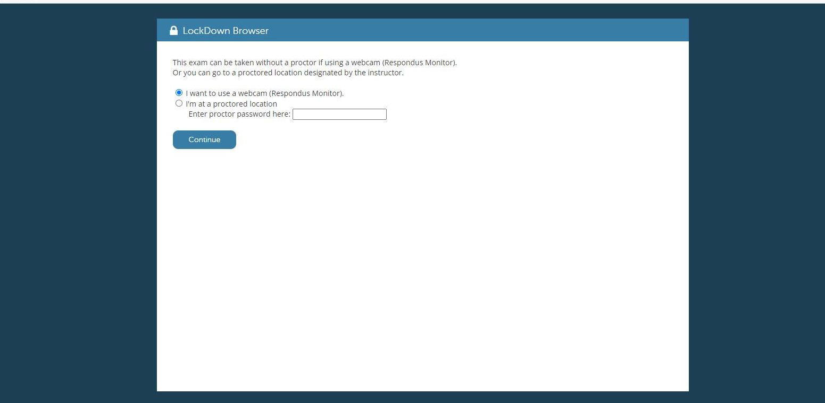

Follow the Respondus Lockdown Browser prompts for photo ID verification, testing workplace scanning, and system check.
After completing the verification steps, click BEGIN EXAM to start your ALEKS Proctored Placement Testing Assessment. The system will record and flag any suspicious behavior for the session. On-campus retest may be required if the system flagged you for any suspicious activity.
Once you complete the assessment, you can exit LockDown Browser to return to your session in your default internet browser.
Next step: Meet with your advisor to discuss the score of the proctored assessment and appropriate math course.

